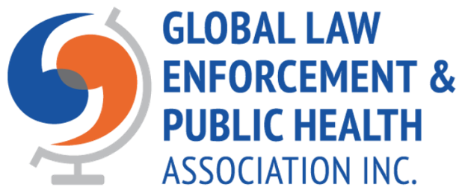

NOTICE of ANNUAL GENERAL MEETING

OF THE

GLOBAL LAW ENFORCEMENT AND PUBLIC HEALTH ASSOCIATION WILL BE HELD:

DATE: Wednesday November 26TH, 2025
TIME: 12:00 PM (1200 hrs) GMT - UTC
VIRTUAL MEETING BY ZOOM

JOINING INSTRUCTIONS:

Important Note: Please sign in 15 minutes before the start of the meeting so that your attendance can be recorded

Join Zoom Meeting
https://us02web.zoom.us/j/85307927256?pwd=RU5cHpqRbe3burOSEEo2IYk7zy1oAW.1

Meeting ID: 853 0792 7256
Passcode: 073885

VIRTUAL VIDEO CONFERENCING FORMAT:

The 2025 Annual General Meeting (AGM) will be held by video conference (Zoom meeting). Consumer Affairs, Victoria, Australia, permits an AGM to be held by Zoom, though requires members to be able to clearly and simultaneously communicate with each other participate member during the meeting. Selecting a time to hold the AGM presents some challenges to allow all members an opportunity to participate if they so desire as our members are geographically dispersed around the globe. We have endeavoured to accommodate as many members as possible in scheduling our AGM.

This notice is being sent to all financial members of GLEPHA. Financial members are those GLEPHA members whose membership are active and paid up at the time the notice is sent.

PURPOSE:

The purpose of an Annual General Meeting is:
- to receive and consider—
  - the annual report of the Board on the activities of the
Association during the preceding financial year; and
  - the financial statements of the Association for the preceding financial year submitted by the Board in accordance with Part 7 of the Act;
- to elect approximately half the members of the Board for a two-year term, and;
- to confirm or vary the amounts of the annual membership fees.

QUORUM:

No business may be conducted at a general meeting unless a quorum of members is present. The quorum for a general meeting is the presence, either physically or by proxy, of 10% of the members entitled to vote. If a quorum is not present within 30 minutes of the scheduled commencement time the meeting must be adjourned. YOU MAY ATTEND VIA ZOOM AND HAVE AN OPPORTUNITY TO PARTICIPATE. IF YOU ARE UNABLE TO ATTEND THE VIRTUAL MEETING YOU MUST SUBMIT A PROXY FORM BY THE SPECIFIED DATE IN ORDER TO RECORD YOUR VOTE.

VOTING:

A person is entitled to vote if they are a financial member or the nominated person from an institutional member; more than 10 business days have passed since he or she became a member of the Association, and; the member’s membership rights are not suspended for any reason. Voting may be exercised in person or by proxy. A member has one vote. An Institutional Membership has one vote only.

Due to holding a virtual AGM voting will be carried out electronically for those participating in the meeting, and by proxy votes received by the deadline. The designated person will report the results of the voting during the live video conference AGM.

A member may appoint another member as their proxy. The appointment of a proxy must be on the designated proxy form, signed by the member making the appointment and submitted by email by midnight (2400 hrs - UTC) Monday November 24th, 2025, to Richard Bent or Bill Stronach, Returning Officers, at the email addresses on the proxy form. The member appointing the proxy may give specific directions as to how the proxy is to vote on their behalf, otherwise the proxy may vote in any matter as they see fit. The designated Proxy Form is attached.

CONTACT:

Should a member have any questions regarding the annual general meeting, contact Richard Bent, President, at rcbent@sfu.ca, Isabelle Bartkowiak-Théron, Vice-President, at isabelle.bartkowiaktheron@utas.edu.au, Bill Stronach, Secretary/Treasurer, at stronachbill@gmail.com.

AGENDA

Global Law Enforcement and Global Health Association
Annual General Meeting
VIDEO CONFERENCE
NOVEMBER 26th, 2025 (12:00 PM – GMT/UTC)

  - Call to Order/Welcome
  - Determination of Quorum
  - Filing Proof of Notice of Meeting
1. Present and Apologies
  - Confirm the Minutes of the 2024 Annual General Meeting
  - Financial Report – Presentation of Audited Financial Statements for Fiscal Year 2023/24. Vote to accept.
  - President’s Report – embedded
  - Vice President Report a Verbal update on Survey from LEPH2025
  - Resolution: Maintenance revisions to the GLEPHA Constitution
  - Election of Vacant Board of Directors Positions:
    - See attached explanatory note and instructions
NOTE: Executive Director update during voting process
  - Close of Business

Agenda Item D.



MINUTES OF ANNUAL GENERAL MEETING HELD ON 19th NOVEMBER 2024
at 12:00 GMT
(by Zoom)
- Present:
Richard Bent (Chairperson), Isabelle Bartkowiak-Théron, Bill Stronach, Isaac Zimba, Glen Blackwell, Megan Parry, Rachel Forbes, Jonas Hansson, Larissa Engelmann, Inga Heyman, Cal Corley, Flora Matheson, Denis Martin, Justin Srivastava, and Richard Southby.

By Proxy: There were three proxies received, Pat Griffin, Jyoti Belur, and Lyndal Bates.

In Attendance: Nick Crofts, Executive Director

- Call to Order: The meeting was called to order at 12:08 PM (GMT/UTC).

- Determination of quorum
A quorum was in attendance

- Opening remarks
Richard Bent, President, welcomed members to the Annual General Meeting and indicated (a) that all correct processes re notification of the meeting had been adhered to and (b) that the business of the meeting is specified (as per the Constitution) in the agenda and no additional business could be considered, although discussion of any issues was acceptable.

- Minutes of last meeting
The minutes from the 2023 AGM held by Zoom on the 21st of November 2023 were made available in the 2024 Notice of AGM sent to all members. A motion to accept the minutes was made by Richard Bent and Justin Srivastava. The minutes were accepted as a true and correct record.

President’s report
This report had been circulated to members with the Notice of Annual
General Meeting. The President noted that many of our Special Interest Groups have been very active and influential, and is one of the more important contributions of GLEPHA. Our membership levels have remained fairly constant, and while the lack of growth has not met the objectives we had hoped to achieve, the interest in the association does seem to be growing. One of the pressing issues facing the association remains the reliance on membership fees for the ongoing operation of GLEPHA and lack of any other sustainable funding source. These will be priorities of the board for the next year, and likely the next couple of years.
There have been successes, in particular the first Trauma-Informed conference in Australia in February of 2024 and upcoming conferences in Pretoria, South Africa in December 2024, Ottawa, July 2025, our first Australasian regional conference in December 2025 and an international conference in Leeds, UK, 2026. Our new initiative Think Tank initiative now has 10 GLEPHA Fellows and they have started to contribute, and we fully expect the Think Tank to evolve as their work becomes better known. The report was accepted.

Treasurer’s report
The Annual Financial Report had been circulated and the Treasurer noted that (a) GLEPHA was solvent and could pay all its debts and (b) the organisation’s balance has diminished over the past year, primarily due to lower membership numbers and our new reduced fee structure. Conferences continue to be the draw for new memberships and the upcoming conferences are expected to lead to increased membership.
A motion to accept the audited financial statements and Treasurer’s report was moved by Bill Stronach and seconded by Richard Southby. The report was accepted.

Vice President’s Report
Isabelle Bartkowiak-Théron presented the results of a survey of the GLEPHA membership. There was a 15% return on the survey.

There were a couple of key findings, being that the members would like to see the website used more by increased uploading new information of interest, and, that they would like to see GLEPHA use social media more.

The slide presentation is included in the appendix of these minutes.

- Executive Director’s comments.
Nick provided a brief overview of current and planned GLEPHA activities and the various global and local challenges facing the LEPH field. Nick updated on the very successful Trauma-Informed Conference in Australia, and advised the First African Regional conference will be held in December, 2024. The planning is well under way for the 7th International Conference in Ottawa, Canada, July 13-16th, 2025. There is enthusiasm for more regional conferences, with plans for the First Australasian conference in late 2025. Finally, early planning is well underway for an international conference in Leeds, UK for the fall of 2026. As GLEPHA’s influence continues to evolve we are attracting more interest from world-class academics and practitioners, and, with that interest we are expanding the range of themes and issues that we’re examining.

The World Federation of Public Health Associations accepted a policy statement from GLEPHA, which we consider a significant milestone.
There are two new Special Interest Groups being formed: Road Safety and Restorative Justice.

- Election of vacant Board of Director positions
Isabelle Bartkowiak-Théron had been appointed the Returning Officer for the board election process.
  - President
Richard Bent was the only nominee and he was declared elected.

  - Secretary/Treasurer
Bill Stronach was the only nominee and he was declared elected.

9.3. Ordinary member positions (2 vacant positions).
There were 3 excellent nominations for two Ordinary Member positions. These positions are for a two-year term.
A confidential poll was conducted via Zoom.

The three nominees were:
    - Larissa Engelmann
    - Megan Parry
    - Richard Southby

Results of election: Isabelle Bartkowiak-Théron, Returning Office, announced that Larissa Englemann and Megan Parry were elected.
All the successful candidates were congratulated and were thanked for their courage in standing for election and for their interest in serving on the board.
- Close of meeting.
The President closed the meeting at 12:54 GMT.

GLEPHA Member Survey

Agenda Item E. – Audited Financial Statements
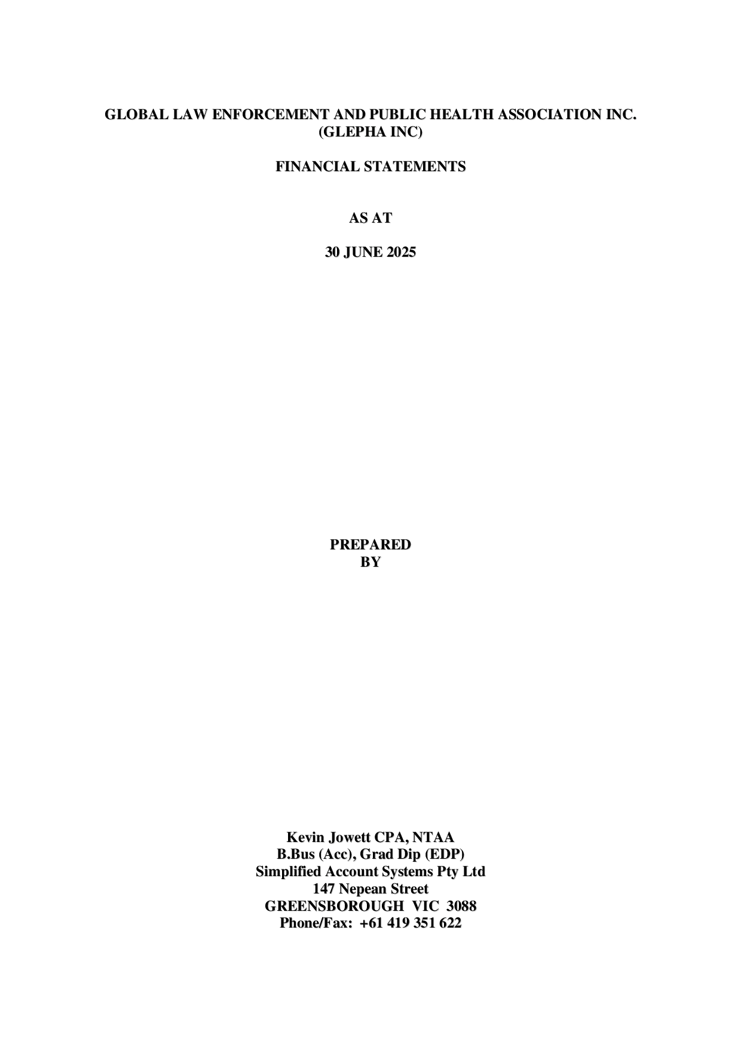

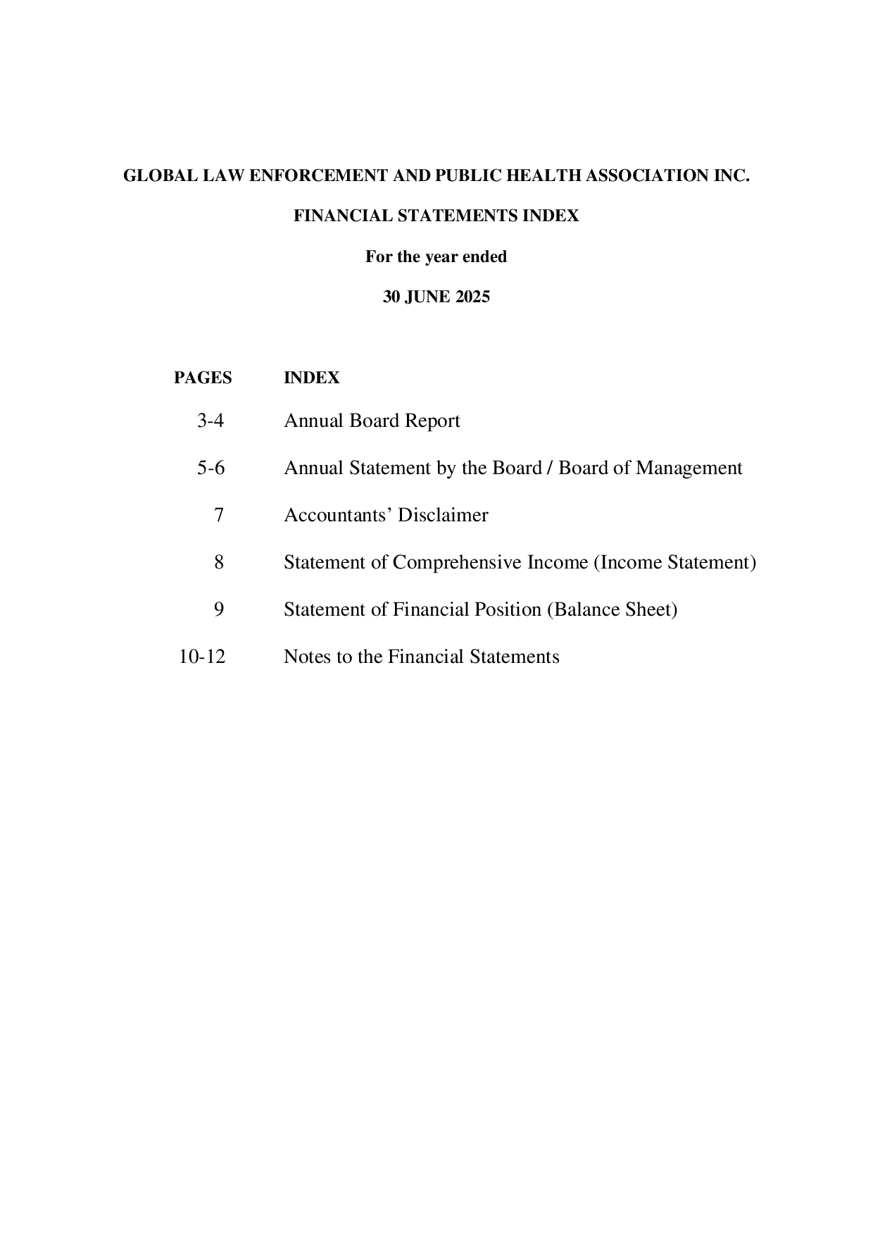
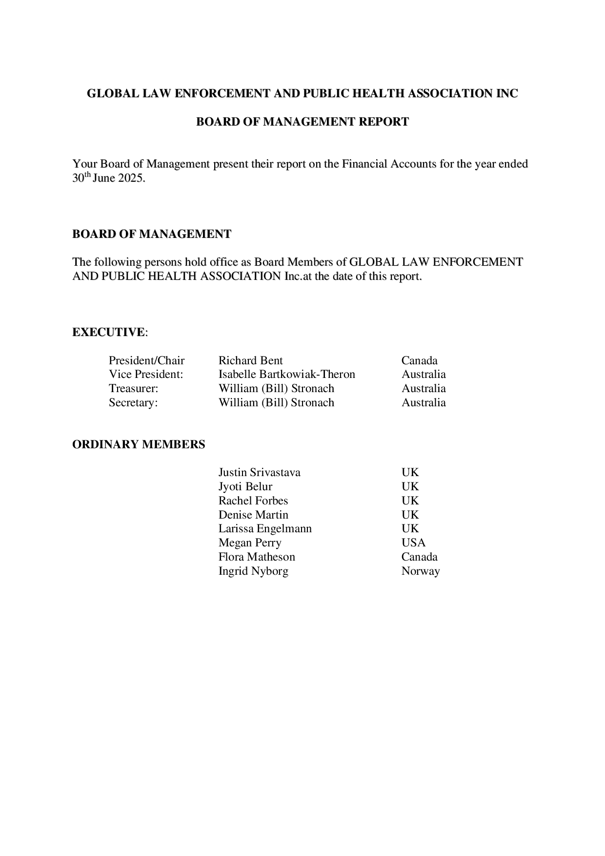
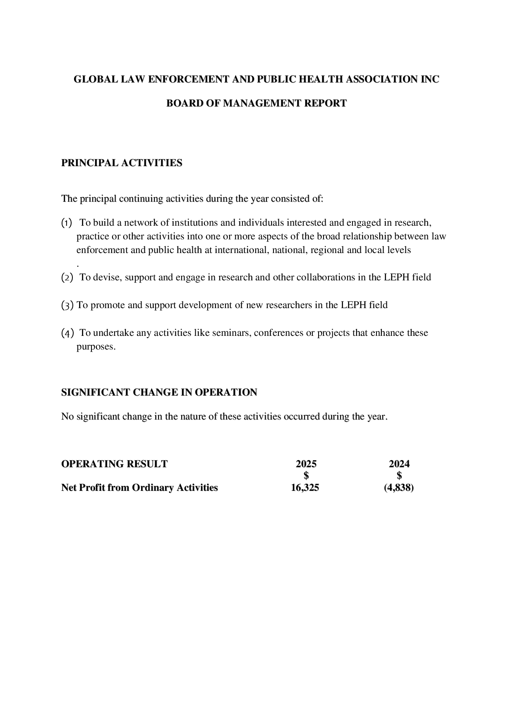
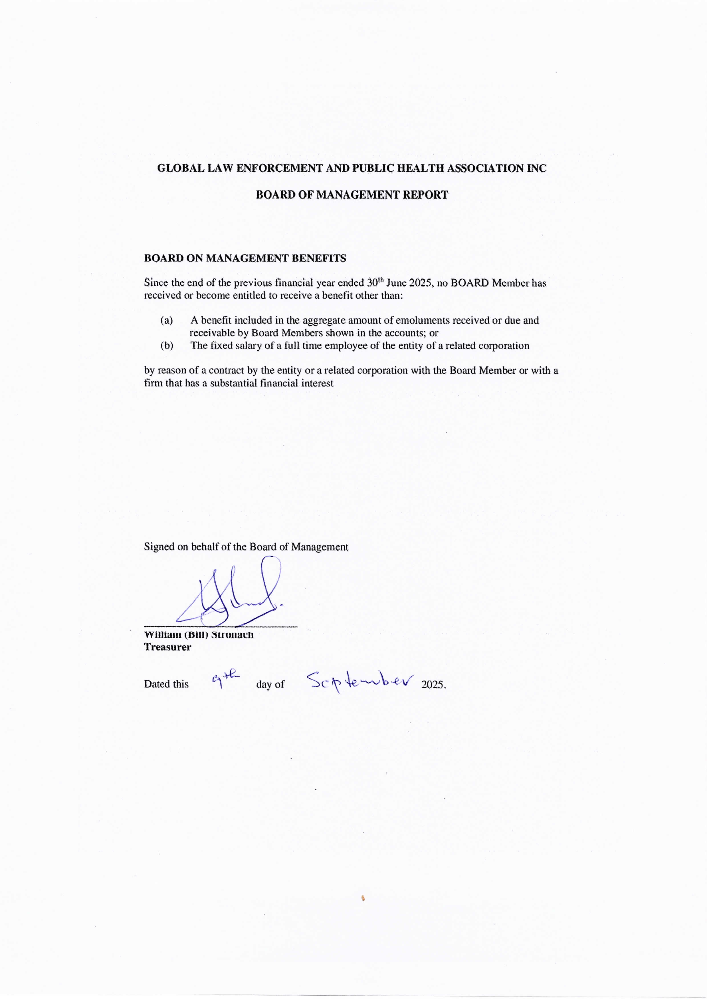
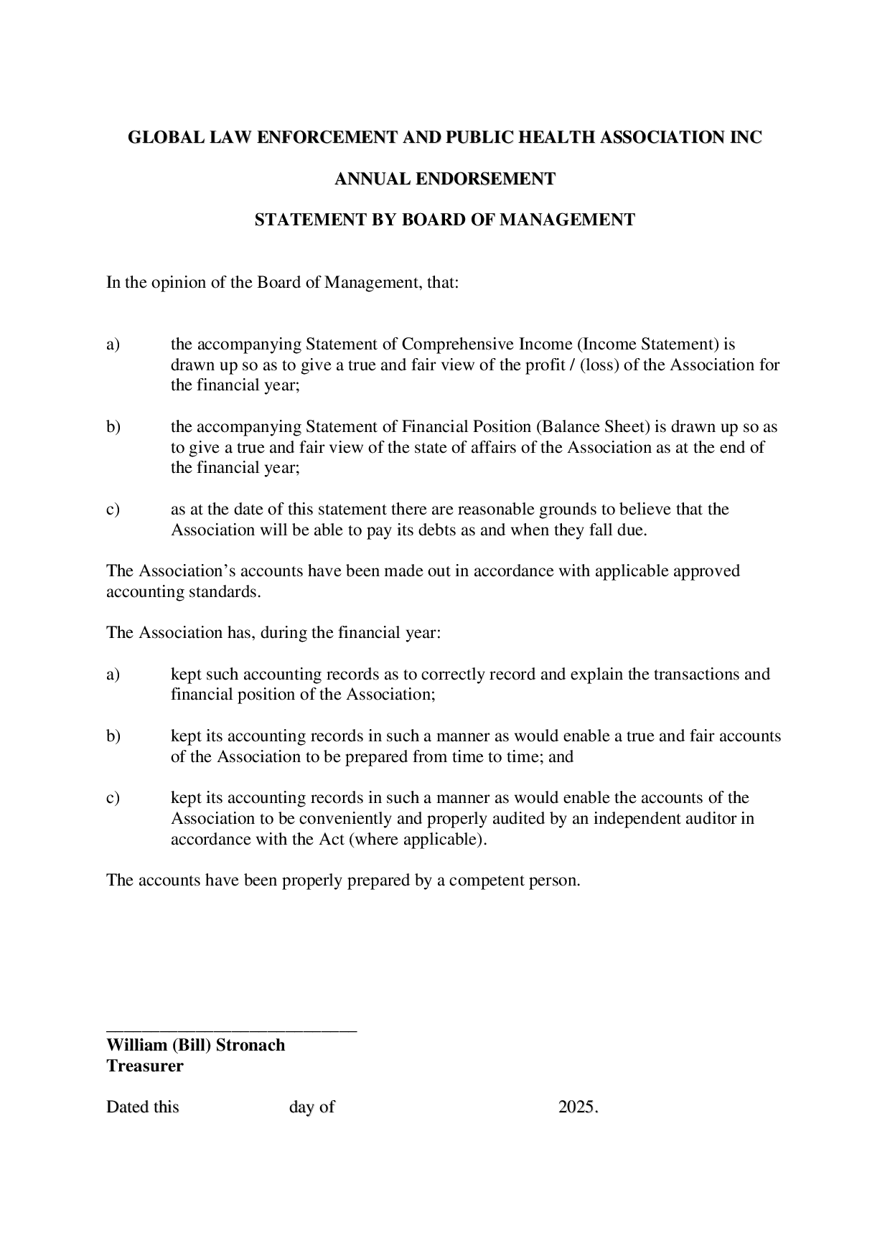
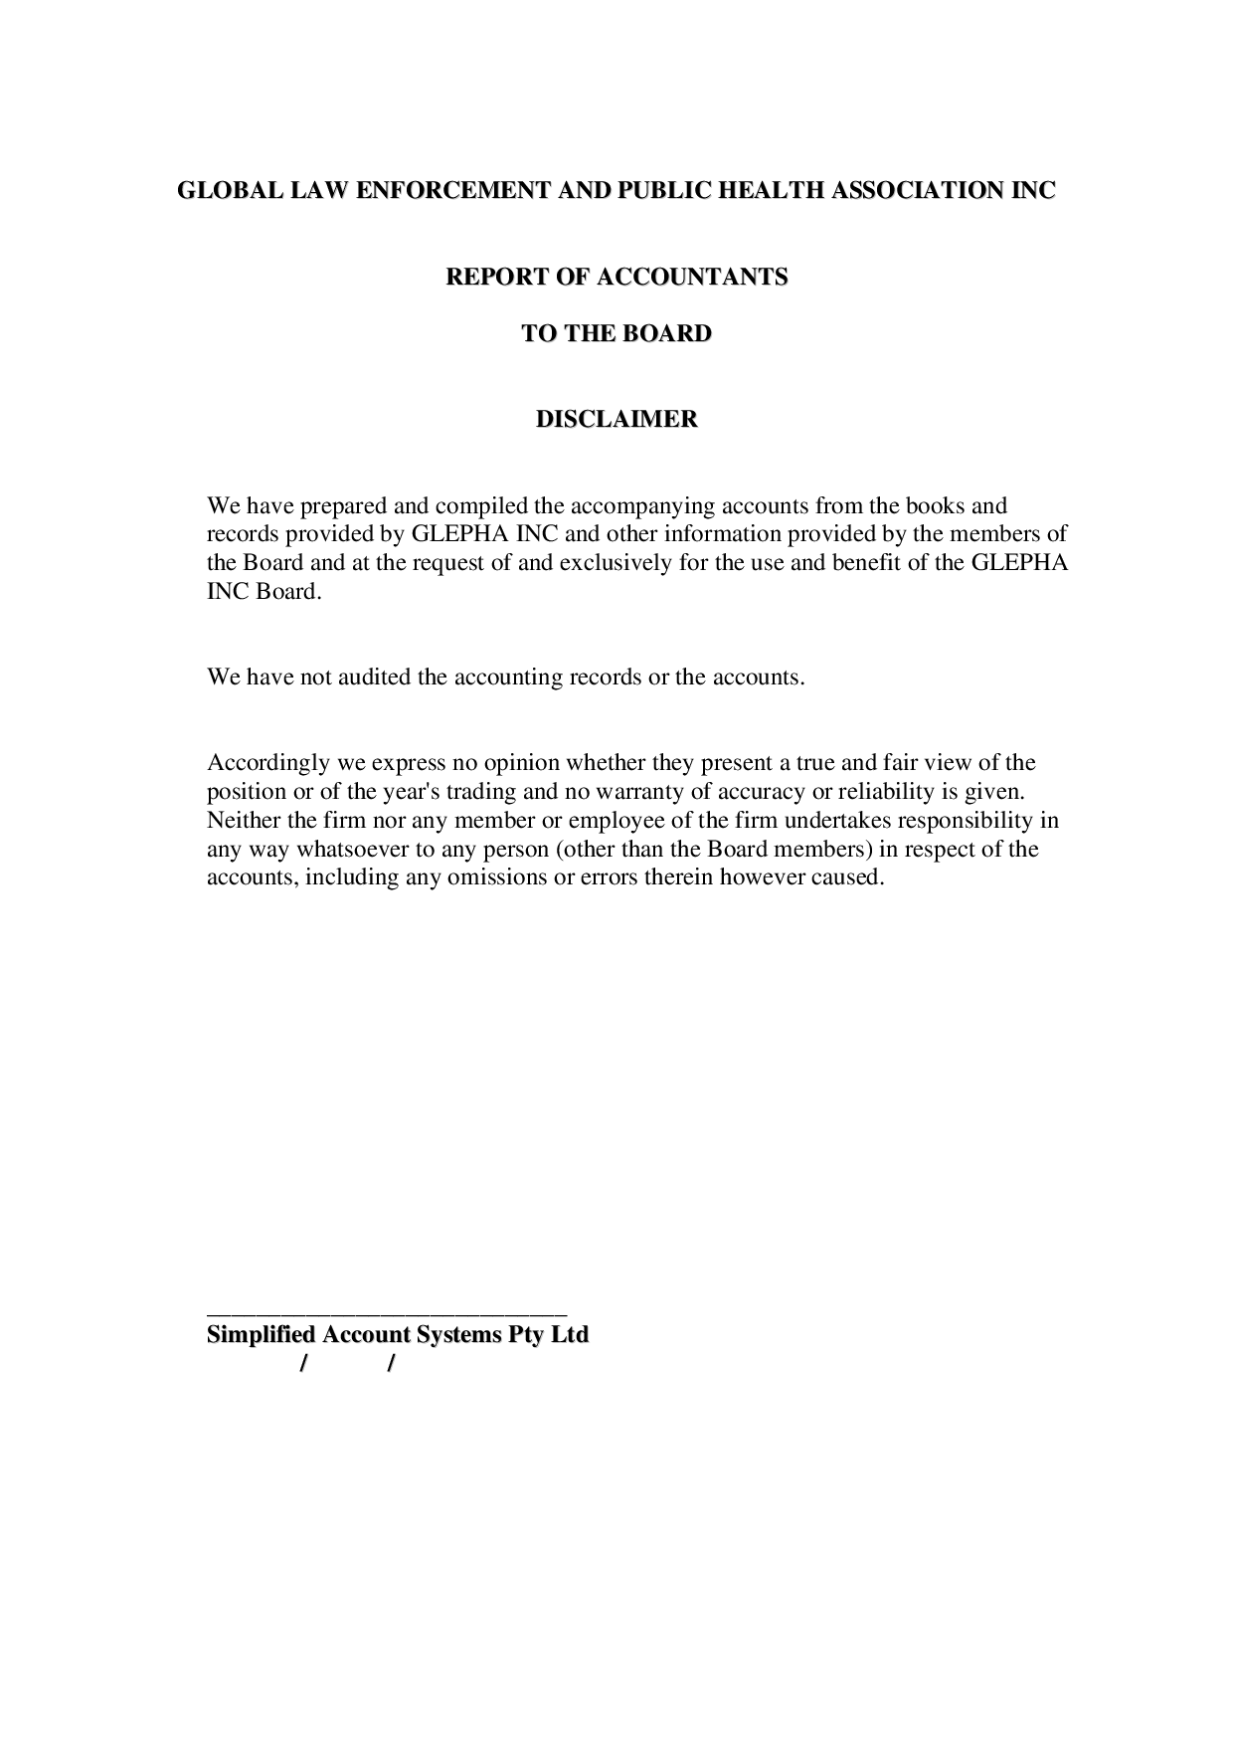
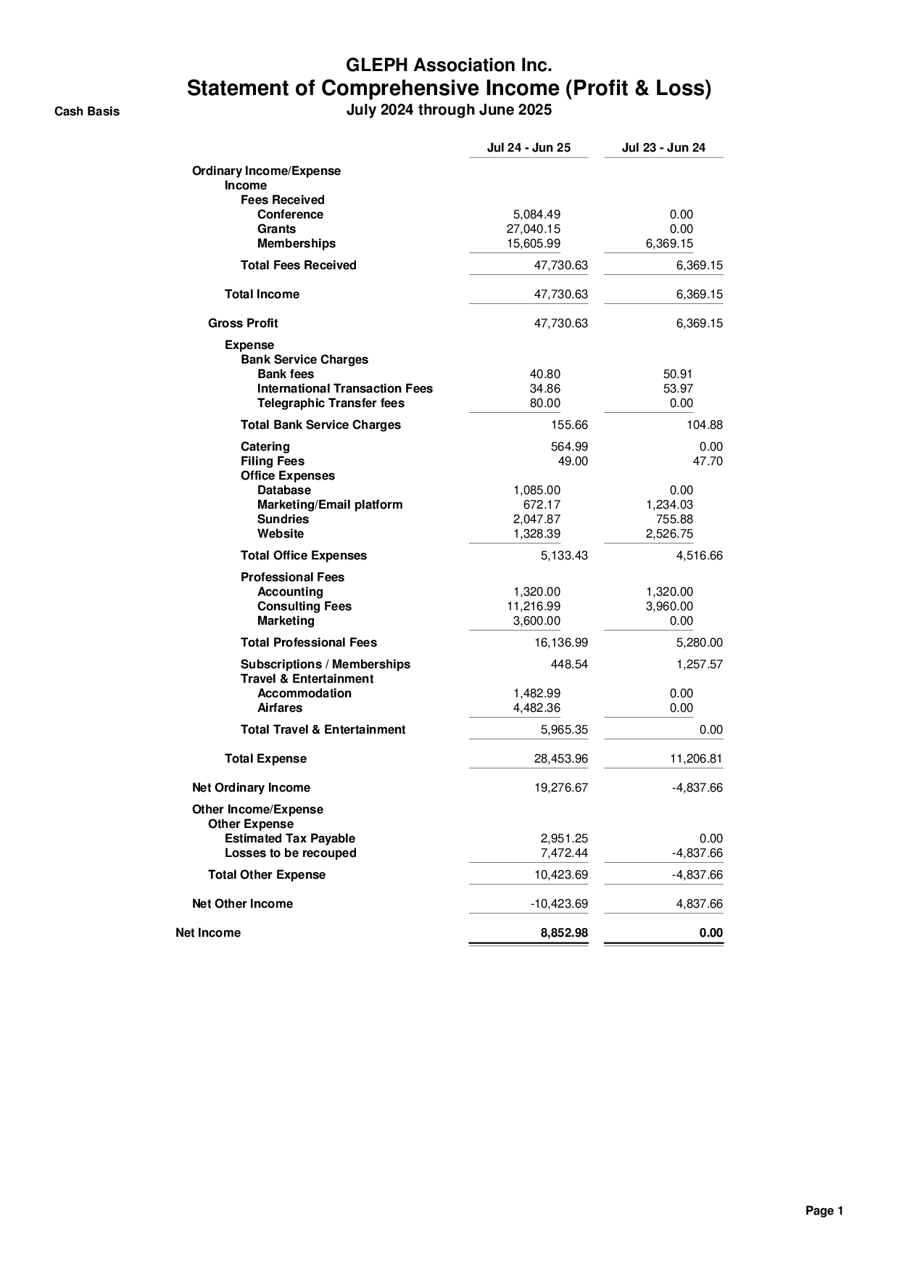
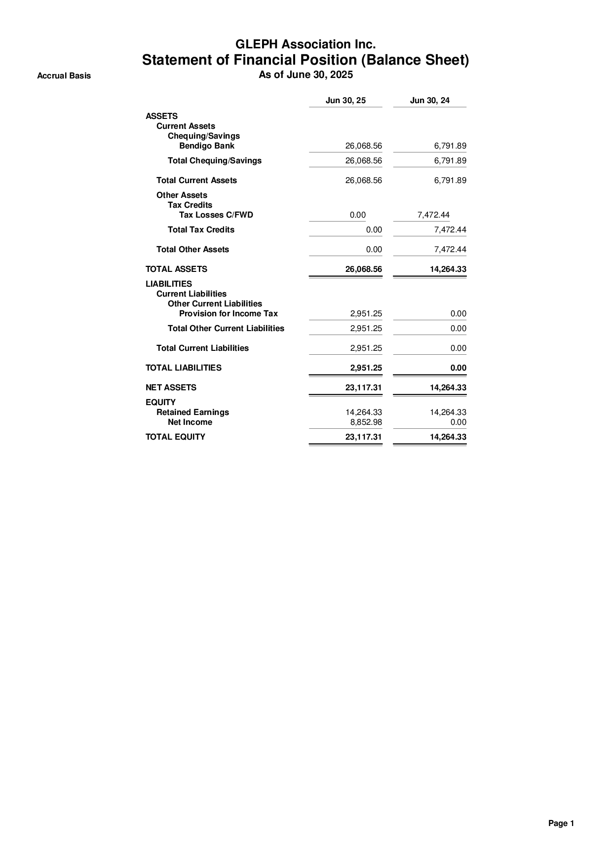
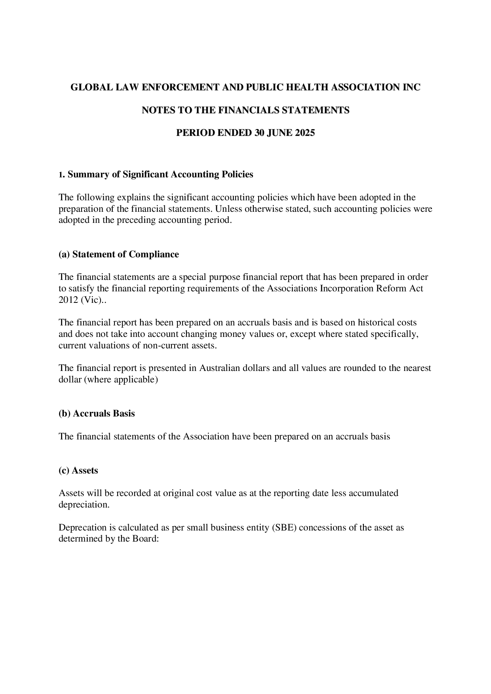

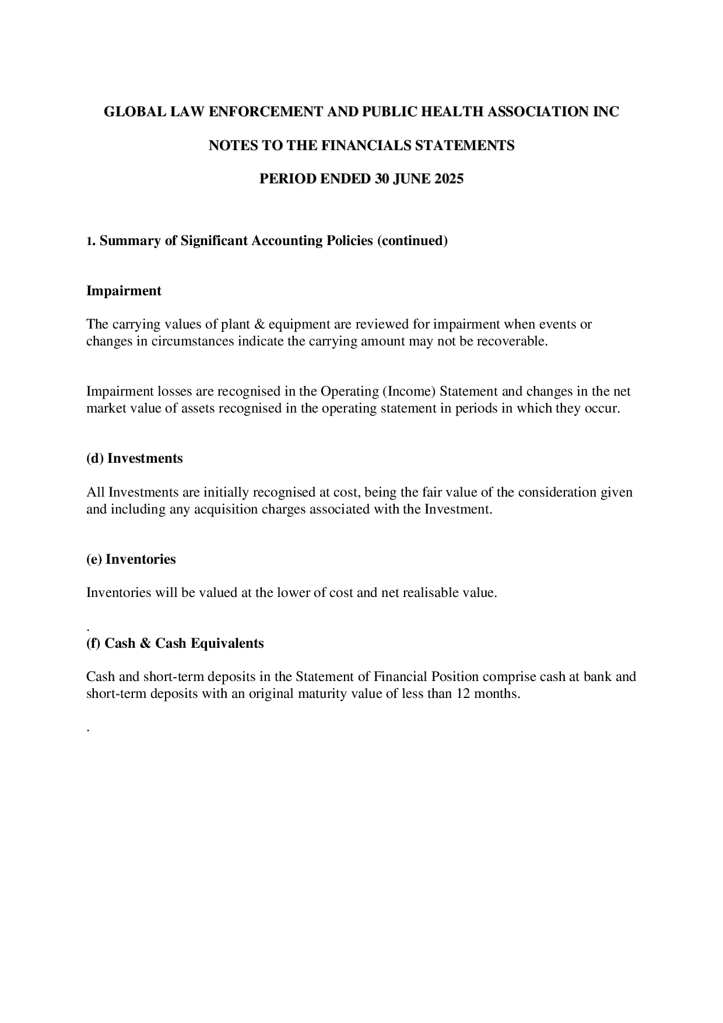
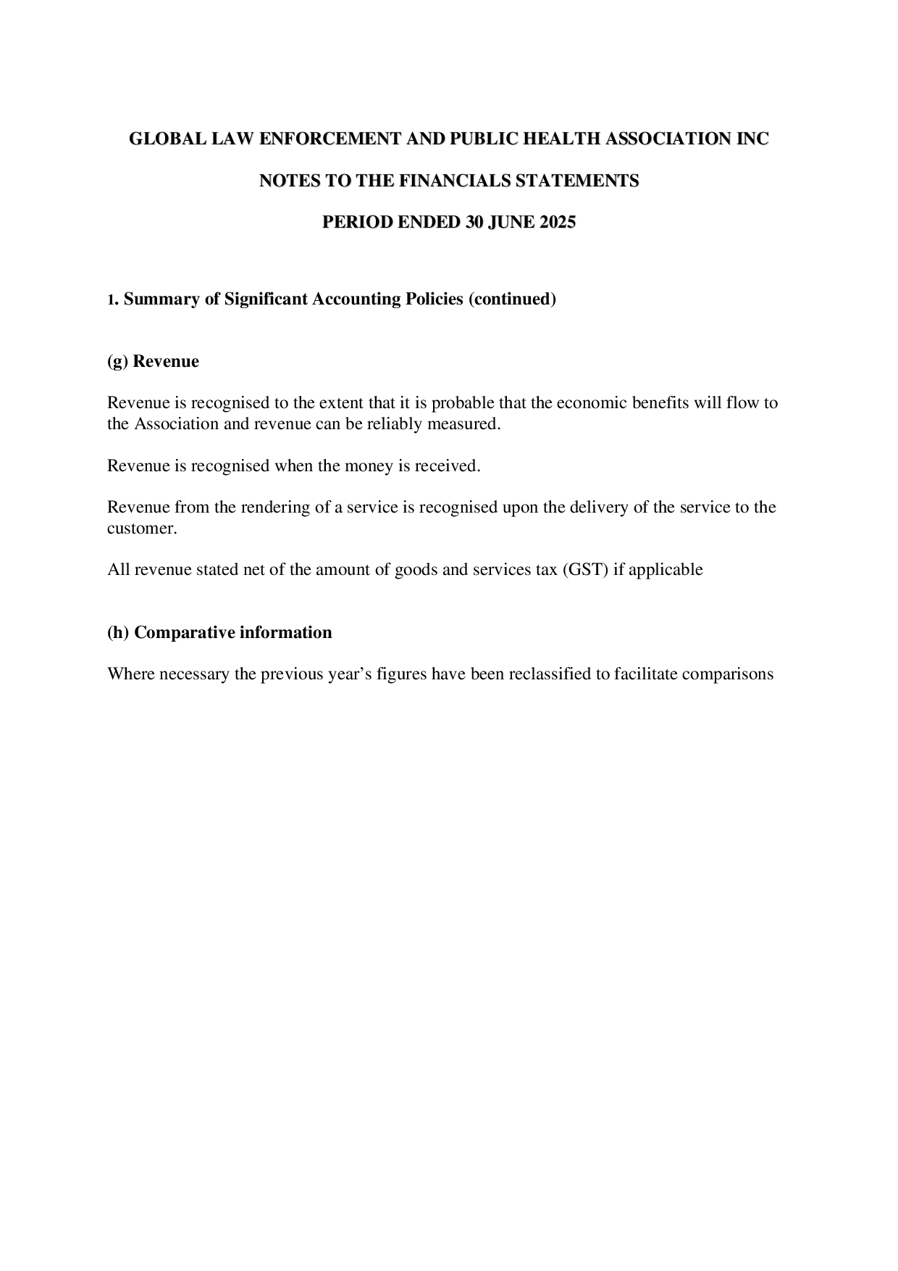

October 18th, 2025

President’s Report to the 2025 Annual General Meeting

I am pleased to present the 2025 President’s Report for the Global Law Enforcement and Public Health Association Inc.
During the past year we saw a very successful 7th International Conference on LEPH, which was the first face-to-face conference since Edinburgh in 2019. The 8th International conference will be held in Leeds, UK, in September 2026. Our Special Interest Groups once again participated in various webinars and conferences. The details of our conferences and Special Interest Groups are elaborated later in this report. We have also been strengthening our relationship with key partners, and in the coming year will work to bring better structure to the functioning of the GLEPHA Board and to GLEPHA’s activities and initiatives.

The LEPH Conferences:

The 7th International Conference on Law Enforcement and Public Health, LEPH2025, was held in Ottawa, Canada, July 2025. The conference was organised in partnership with the University of Ottawa, Centre for Health Law, Policy and Ethics We pre-conference sessions. The Centre of Health Law, Policy and Ethics were wonderful and engaged partners and excellent hosts in the City of Ottawa. A number of mentionable pre-conference sessions were held, those being: Masterclass on Women, Police and Security: Global Perspectives and Challenges, our usual Post Grad Studies Event, and, First Contact: Supporting Police Response to Intimate Partner Violence and Brain Injury Workshop.

The Masterclass on Women, Police and Security sessions the Masterclass advocated for the future of women in policing and security, the link to the recorded sessions is here: https://www.youtube.com/watch?v=z_QknZLybpE.

During the past year we saw finalising the establishment of our first regional network, the African Regional LEPH Network, https://glepha.com/alephn/. The network covers sub-Saharan Africa, which aims to develop collaboration between law enforcement and public health focusing on issues unique to the region. The first African Regional conference took place in Pretoria in December 2024. The overarching theme of the African Regional conference is ‘Aligning Policing and Public Health: Working Together for Community Wellbeing.’ The link to the conference website: https://leph2024pretoria.com. Since the creation of the ALEPHN there have been regional workshops in 8 countries and the Coordinator has spoken at the Eastern and Southern Africa Commission on Drugs.

Finally, planning is proceeding well for the 8th International LEPH Conference,
Leeds, UK, 6th – 9th September, 2026. This conference is co-sponsored by the UK Economic and Social Research Council, Vulnerability & Policing Futures Research Centre, York University and Leeds University. The program for the Leeds conference is developing very well, with the themes of the conference published on the website. Anyone interested in the Leeds, LEPH2026, conference can sign up for updates at: https://leph2026.org.

A measure of the success of GLEPHA and the International LEPH conferences is, following the Ottawa conference, a number of organisations have approached GLEPHA expressing interest in co-hosting international conference. There is good potential to see our vision of annual international conferences start to come to fruition. We have invitations from interested partner agencies to organise international conferences in 2027, 2028 and 2029.

Initiatives:

Review and update the structure and governance functioning of the Board

Our GLEPHA Board has embarked on a review of the Board structure and governance model to improve its functioning. It is inevitable that over the past 8 years that we needed to adjust our structure and business practises. While we do want to make adjustments, one thing we don’t want to lose the small association ‘feel.’ The outward appearance won’t change; however, the aim is to prepare the association for the future as we grow and mature.

Think Tank

In the fall of 2023, we announced the formation of a Think Tank comprised of GLEPHA Fellows. We now have appointed 10 GLEPHA Fellows, from both the public health and police backgrounds, who bring expertise and leadership in their respective fields. The Think Tank mandate is to develop position papers for GLEPHA; to receive requests from the Executive Director, Board Members, and SIG Convenors, and; to develop their own areas of exploration. The Think Tank will also respond to questions from GLEPHA members, explore and suggest ways for GLEPHA to communicate or engage government agencies, etc., in order to turn initiatives into action, and, will write articles, editorial opinions, etc. To date a regular Fellow’s Blog has started for the GLEPHA newsletter, and they have contributed to the development of GLEPHA’s policy statement for the World Federation of Public Health Associations (WFPHA).

Membership and Funding:

GLEPHA membership numbers have remained quite constant over the past few years, not fluctuating much.
We still aim to expand our membership to low-and-middle income countries. You will recall that we created a new fee structure to recognizing the financial pressures many face in many countries.
Our Board of Directors ask all our members to actively promote GLEPHA. Our efforts are making a significant contribution to the field of law enforcement and public health, and our own collaborative effort to support our association is vitally important to the future of GLEPHA.
The following it the link to join GLEPHA: https://glepha.com/join-us/

Special Interest Groups (SIGs):

The SIGs continue to be one of our most successful initiatives covering a wide variety of LEPH issues. There is a renewed interest in the Road Trauma SIG, and an interest in establishing a First Nations/Indigenous SIG.
Our Education SIG has been busy as well. They will be organized more student awards and have plans for a student workshop at the LPEH2026 conference and that saw the launch of the GLEPHA student network. The network benefits from online workshops, resource materials and networking, all of which will be free of charge for students.
More information about the SIGs is on the website and if you have any ideas or would like to join a group, please contact our Executive Director, Nick Crofts at nick.crofts@unimelb.edu.au.

One of the benefits we can offer our members is that the GLEPHA website is a good repository of resources in the LEPH field; I encourage everyone to submit any useful articles, reports, videos, blogs etc., for inclusion in the Resources section of the GLEPHA website.
Though our association has accomplished, there is certainly more we can accomplish. With the support of our membership and of our partners and affiliates, we will strive to achieve even more. Our key priorities will remain largely consistent for the next few years, primarily:
- The Board will be reviewing and revising our structure to improve the functioning of the GLEPHA Board and to GLEPHA’s activities and initiatives. As we mature, we need to ensure our structure continues to properly support our aims and objectives.
- Further develop our Strategic and Communication Plans for GLEPHA, including development of further strategic alliances and partnerships
- GLEPHA has lacked good sustainable funding which has limited our growth and ability to fully achieve our aims and objectives. We will increase efforts to secure a dependable funding source to bring some permanence to our association structure;
- Look at the viability of developing other regional LEPH networks that will have close association with GLEPHA, but will focus on regional relationships and regional concerns.
- Increase both organizational and individual membership;
- Leverage the good work being done by the current Special Interest Groups, our GLEPHA Fellows, and link them to the Conference Program planning and standalone events;
- Work with key partners to organise annual international conferences, and support more regional conferences.
- Look to host more virtual, focused initiatives such as the Marketplace of Ideas; and,
- Further our developmental opportunities for Masters and PhD candidates and other LEPH educational and research strategies.

It is important to acknowledge the contributions of the Board of Directors in working with the individual SIGs and in carrying out the duties of the Board. Rachel Forbes served on our Board for the past 2 years and has recently resigned. She brought her experience from the public health sector and was an active contributor to the Board and was the Board Representative on the Violence Prevention SIG. Rachel was one of exceptionally accomplished individuals on our Board.
Once again, it is important to recognize the leadership and drive of our Executive Director, Professor Nick Crofts. Through Nick’s tireless work, we have received interest from a number of potential partners to plan and organise international LEPH conferences for the next few years. Nick has navigated the very promising development of the African Regional LEPH with partners in Africa, and the organisation of the first African Regional LEPH conference.
We have been particularly blessed with the support of Cearet Sood, our Communications Manager, and Vy Doan, or Coordinator. Both are very dedicated and bring much needed support to our association. Cearet has been instrumental in working with the Special Interest Groups, and area that needed some better coordination from the Board level.
The interest in the field of law enforcement and public health is increasing and becoming more recognised. We should be proud of what we have accomplished in the past almost 9 years. The objectives of GLEPHA to explore public health approaches to law enforcement are as relevant as ever, maybe more so.

Finally, I thank all our members and all those who have worked so closely with GLEPHA. It is through our efforts that we will make a difference.

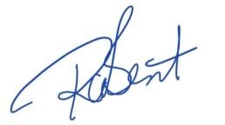
Richard Bent
GLEPHA President

309 George St.,
Doncaster, Victoria, Australia 3108
www.glepha.com

Agenda Item. H. – Resolution to Amend GLEPHA Constitution

This resolution is a maintenance amendment to the GLEPHA Constitution to reflect changes to the terms of memberships for the categories of memberships. This represents changes to better accommodate association members’ needs for terms of membership.

Special Resolution:

Amendment to Section 7(2) of the Rules of the Association

Motion: That,

“The term of membership will be either one (1), 2 (two), or 5 (five) years commencing on payment of the membership fee”

be deleted and replaced by:

‘The term of the membership will be one (1) year for individual membership and 2 (two) years for institutional membership commencing on payment of the membership fee.”

Agenda Item I.

Election of Vacant Board of Directors Positions – Explanatory Notes
The Board consists of—
- a President; and
- a Vice-President; and
- a Secretary; and
- a Treasurer; and
- not more than 5 ordinary members.

As the GLEPHA is incorporated in Australia, the position of Secretary must be held by a person residing in Australia. The positions of Secretary and Treasurer may be held by the same person, and will be combined for upcoming two-year term.

Election of Board positions is for a two-year period, therefore, to comply with the Constitution of the GLEPHA, an election of approximately half the board members occurs every year.

The following positions will be vacated and an election held at the 2025 Annual General Meeting:

  - Vice President, and
  - 3 Ordinary Members

The Notice of a Call for Nominations was sent to all financial members of GLEPHA on October, 22nd, 2025, as part of this Notice. Emailed nominations close at 5:00 PM (GMT-UTC) November19th, 2025.

Nominations
    - Prior to the election of each position, the Chairperson of the meeting must call for nominations to fill that position.
    - An eligible member of the Association may—
      - nominate himself or herself; or
      - with the member's consent, be nominated by another member.
    - A member who is nominated for a position and fails to be elected to that position may be nominated for any other position for which an election is yet to be held.

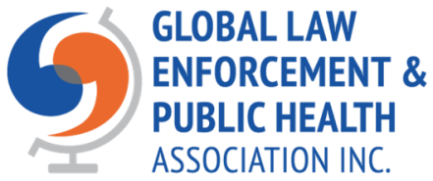
ANNUAL GENERAL MEETING
GLOBAL LAW ENFORCEMENT AND PUBLIC HEALTH ASSOCIATION
PROXY FORM

I, ______________________________________________________________________, of _____________________________________________________________________,
a member in good standing of the Global Law Enforcement and Global Health Association hereby appoint: ______________________________________________________
as my proxy for me and on my behalf at the Annual General Meeting to be held November 26th, 2025, and at any adjournment thereof.
Signed this _______ Day of ___________________________ 2025.

(Member signature)
Note: In assigning a proxy ensure you provide instruction with respect to your vote on acceptance of the Financial Statements and with respect to voting for Board positions. In absence of specific instructions, the assigned proxy will use their discretion and best judgement in voting on your behalf at the AGM.
Proxy form to be emailed to either Returning Officer, Bill Stronach at: stronachbill@gmail.com, or Richard Bent at rcbent@sfu.ca.

