

**ANNOUNCEMENT**

**Board of Directors – Election Results**

We are pleased to announce that the following GLEPHA members were elected to the Board of Directors at the Annual General Meeting held November 19th, 2024:

President: Richard Bent (Canada) re-elected

Secretary/Treasurer: Bill Stronach (Australia) re-elected

Ordinary Members: Larissa Engelmann (UK)

Megan M. Parry (US)

Each were elected to their positions for a two-year term - 2024-2026. Larissa and Megan are new members on the Board and bring considerable experience and passion to these roles.

We wish to acknowledge the contributions of the members who left the Board of Directors at the end of their terms, and to wish them well. They are, Dr. Patricia Griffin, Holy family University, and Dr. Richard Southby, George Washington University. Both Patricia and Richard have been valued Board members of the GLEPHA Board and both have committed to continued contribution to GLEPHA initiatives.

Richard Southby has accepted an appointment as a GLEPHA Fellow, working with our other Fellows on our Think Tank researching relevant and pressing issues for all those working in the law enforcement and public health domains.

We welcome the new members to the GLEPHA Board of Directors.

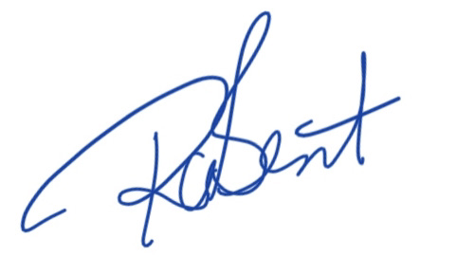

Richard Bent

GLEPHA President

November 19th, 2024