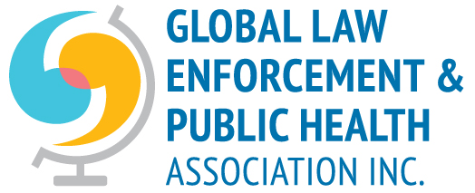

2018 ANNUAL GENERAL MEETING
Notice is hereby given that the Annual General Meeting
of the
Global Law Enforcement and Public Health Association Inc. (GLEPHA Inc)
is to be held at the
Hart House (Common Room)
7 Hart House Circle
University of Toronto
on
Sunday 21 October 2018 at 2.00 p.m.

The business of the Annual General Meeting shall be:
- Welcome and confirmation of those eligible to vote, proxies and apologies

- Minutes from the last Annual General Meeting.

- Business arising from the previous minutes.

- President’s report

- Financial report including the Annual Financial Statements.

- Election of Board Office bearers and Ordinary members6.

7. Other business of which at least 7 days notice has been provided.

*Apologies to Richard Bent, GLEPHA Vice President at rcbent@sfu.ca

